COMPUTER TECHNOLOGY
EXCEL ASSIGNMENT 1 PART A

- Open our Excel worksheet.
- A blank workbook opens.
- You will complete the worksheet below by completing the steps:
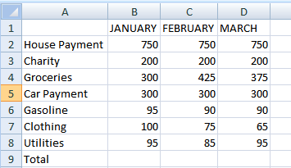
- Leave cell A1 blank. I cell B1, key the column heading JANUARY. TAB
- The pointer moves to cell C1. Key FEBRYARY (The word does not show completely. You will adjust the width later.) Press tab again.
- The pointer moves to cell D1. Key MARCH and press tab or the right arrow key.
- Click with your mouse in cell A2. Key House Payment. Press the Enter key.
- The pointer moves down to cell A3. Key Charity. Press the Enter key.
- Continue typing the row heading items in Column A.
- Move the pointer to cell B2 and type the numbers for January in column B. You can use the arrow keys to move from cell to cell or press Enter to move down a cell and tab to move over a cell.
- Move the pointer back to cell B2. You will copy the number in cell B2 to and cells C2 and D2.
- Click the Copy button on the Standard toolbar. (It is in the Home tab, next to the word paste and under the scissors.) A moving marquee surrounds the cell.
- Select the cells C2 and D2.
- Click the Paste button. This will paste cell B2 into C2 and D2.
- Click the escape button to de-select the cell.
- Continue entering the rest of the numbers for February in column C and March in column D. You may want to use the Copy and Paste function for some of the cells.
- Adjust the column widths by following these steps:
- Make cell A2 active. On the Home tab, click on Format and scroll down to Auto fit column width. Click.
- Move to cell C2. Click on Format/Column Width.
- A column width box appears with 8.43 as the current column width. Key 10.00.
- Select the column headings in B1 to D1 and change format to Bold.
- Save the workbook as First Initial Last Name Excel 1A.
- Turn in Assignment as directed.

