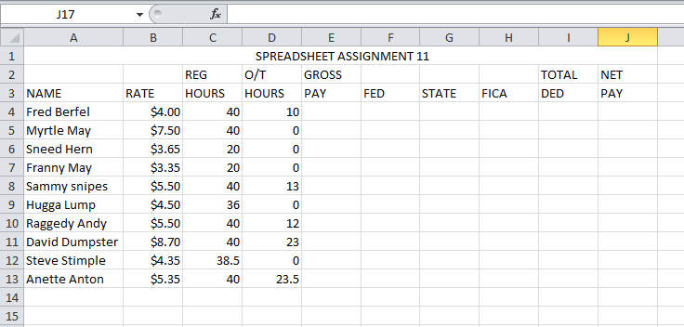

Formulas should be entered only ONCE at the top of each column and copied down the columns using the fill handle (small black plus sign in the lower left hand corner of the cell.)Enter formulas at the top of the columns similar to the following:

GROSS PAY: =(Reg. Hours * Rate) + (O?T Hours * (1.5 * Rate))
Example: =(C4*B4) + (D4*(1.5*B4))

FEDERAL: 15% of GROSS PAY
Example: =E4*.15

STATE: 28% of FED.
Example: =F4*.28

FICA 75% (.075) of GROSS PAY
Example: =E4*.075

TOTAL DED. FED + STATE + FICA
Example: = F4 + G4 + H4

NET PAY: GROSS PAY – TOTAL DED.
Example: = E4 – I4

*Remember to put an = sign before all formulas.

*Format all amount columns to currency.

*Center or rights align Column Heading in B through J. Make your spreadsheet look nice.

*Make sure your name is on your assignment and turn in as directed.

