COMPUTER TECHNONOGY
EXCEL ASSIGNMENT 3

- Open a new Excel Workbook
- Create the worksheet shown below.
- The title in Row 1 should be 14 point bold.
- Bold the teacher name and Class Roster.
- Change the font in Row 8 to 11 point and bold.
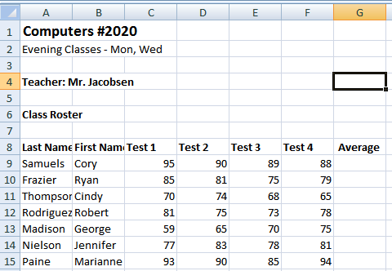
- You will now use the AVERAGE Function to calculate the mean of a range of cells. The Arithmetic mean adds the values in the cells and then divides by the number of values.
- Click in cell G9. You want to place the average of the values from columns C through F in G9.
- Click the Insert Function button (fx) on the formula bar.
- Choose Statistical in the Or select a category list.
- In the Select function list, locate AVERAGE.
- Click AVERAGE to see its syntax and description. Click OK.
- The Number 1 box shows the range C9:F9.
- Click OK. The result of 90.5 is formatted in a General number.
- Copy this formula down to cells G10:G15.
- You will now use the MAX Function to find the highest number of each test given.
- Click cell A 18 and key MAXIMUM
- Click cell A19 and key MINIMUM
- Click in cell C18.
- Key =MAX(
- With your mouse, click cell C9 and drag to select cells C9:C15
- Key )
- Press Enter. The Maximum (highest) test score for Test 1 is 95.
- You will now find the Minimum (lowest) number of each test using MIN
- Click in cell C19.
- Click the Insert Function button (fx) on the formula bar.
- Choose Statistical in the category and scroll down to find MIN
- Click OK
- When the function argument dialog box displays, type C9:C15 in the Number 1 box
- Click OK. The Minimum number of 59 appears.
- Copy these formulas to the other tests columns.
- Select cell C18 and C19
- Click the Copy button on the Standard toolbar.(on the Home tab, under the scissors)
- Select cells D18 through F 19
- Click the Paste button on the Standard toolbar
- The Maximum and Minimum numbers for each test will be displayed.
- Press the ESC key to cancel the moving marquee.
- You will now use the COUNT function to tally the number of values (items) in a range.
- Click cell A21
- Key NUMBER OF TESTS
- Press Enter
- Click in cell G21
- Key =COUNT(G9:G15)
- Press Enter
- The number of people taking the test id displayed.
Save your workbook
- Hold down the control button and push the Tilde key (above the tab key) so the formulas show. (Your teacher will check this to see the formulas are correct.)
- If you are instructed to print this assignment:
- Change the page orientation to landscape.
- Select Print Preview
- Select Page Set up
- Fit page 1 to 1
- Turn in as directed.

