COMPUTER TECHNOLOGY
EXCEL ASSIGNMENT 5
Create Embedded Chart
- Open a new workbook.
- Create the worksheet below.
- Use proper formatting. Make sure you adjust the column width.
- Rename Sheet 1 as Nevada Shops.
- Calculate each store’s total and each week’s total. If a column has ######, adjust the column width to fit the number.
- Format the Store totals and Weekly Totals as currency with 2 decimals.
- Select the cells in the column or row.
- Right mouse click and choose Format Cells. (Or go to Format/Format Cells)
- Choose Currency in the category box
- Choose 2 as decimals
- Click OK
- Type your name and Excel Assignment 5 two rows below the Weekly Totals.
- Save the worksheet as Excel Assignment 5 and leave on your screen.

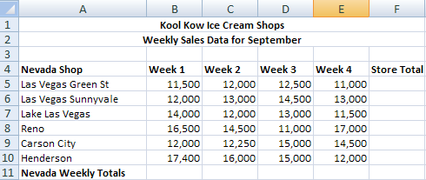

- You will now create an embedded chart.
- Select cells A4 to E10.
- Go to the Insert tab on the standard toolbar.
- Select Column Chart/select the 1st 3D chart.
- The chart displays in the middle of the window in a rectangle.
- Click and Drag the chart so that the upper edge of the chart sits between cells A16 and G16, and the bottom edge of the chart sits between cells A30 and G30.
- Save as Excel Assignment 5.
- Hand in according to instructions.

