Name: _________________________________

Instructions: Complete the following handout as you take apart your assigned computer and discuss with the teacher and classmates.

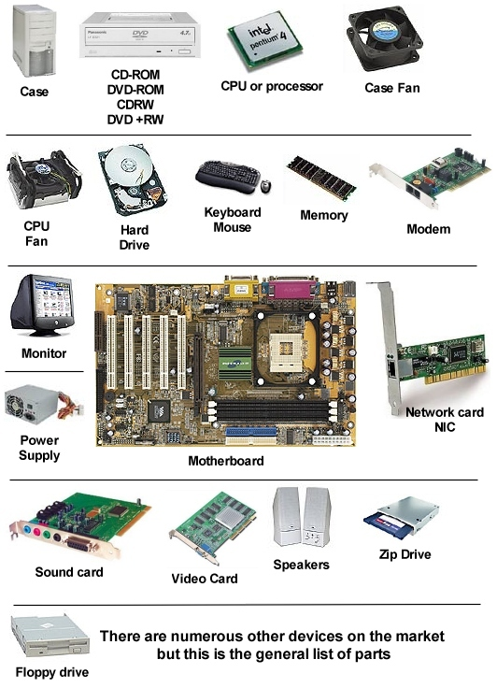

__________

__________

__________

__________

[Type a quote from the document or the summary of an interesting point. You can position the text box anywhere in the document. Use the Drawing Tools tab to change the formatting of the pull quote text box.]

__________

__________

__________

__________

__________

__________

__________

__________

__________

__________

__________

__________

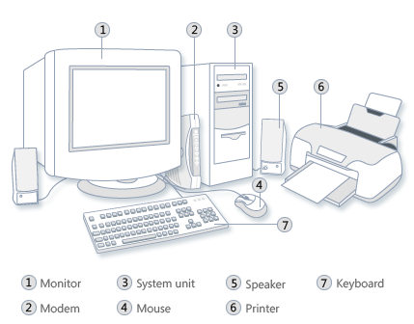

1. __________________________
2. __________________________
3. __________________________
4. __________________________
5. __________________________
6. __________________________
7. __________________________

Categorize each component listed on the last two pages as in one of the following function categories:

1. Input Devices:
2. Output Devices:
3. Storage Devices
4. Processing components: