COMPUTER TECHNONOGY
EXCEL ASSIGNMENT 3

- Open a new Excel Workbook
- Create the worksheet shown below.
- The title in Row 1 should be 14 point bold.
- Bold the teacher name and Class Roster.
- Change the font in Row 8 to 11 point and bold.
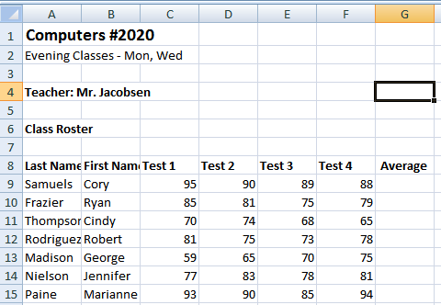
- You will now use the AVERAGE Function to calculate the mean of a range of cells. The Arithmetic mean adds the values in the cells and then divides by the number of values.
- Click in cell G9. You want to place the average of the values from columns C through F in G9.
- Click the Insert Function button (fx) on the formula bar.
- Choose Statistical in the Or select a category list.
- In the Select function list, locate AVERAGE.
- Click AVERAGE to see its syntax and description. Click OK.
- The Number 1 box shows the range C9:F9.
- Click OK. The result of 90.5 is formatted in a General number.
- Copy this formula down to cells G10:G15.
- You will now use the MAX Function to find the highest number of each test given.
- Click cell A 18 and key MAXIMUM
- Click cell A19 and key MINIMUM
- Click in cell C18.
- Key =MAX(
- With your mouse, click cell C9 and drag to select cells C9:C15
- Key )
- Press Enter. The Maximum (highest) test score for Test 1 is 95.
- You will now find the Minimum (lowest) number of each test using MIN
- Click in cell C19.
- Click the Insert Function button (fx) on the formula bar.
- Choose Statistical in the category and scroll down to find MIN
- Click OK
- When the function argument dialog box displays, type C9:C15 in the Number 1 box
- Click OK. The Minimum number of 59 appears.
- Copy these formulas to the other tests columns.
- Select cell C18 and C19
- Click the Copy button on the Standard toolbar.(on the Home tab, under the scissors)
- Select cells D18 through F 19
- Click the Paste button on the Standard toolbar
- The Maximum and Minimum numbers for each test will be displayed.
- Press the ESC key to cancel the moving marquee.
- You will now use the COUNT function to tally the number of values (items) in a range.
- Click cell A21
- Key NUMBER OF TESTS
- Press Enter
- Click in cell G21
- Key =COUNT(G9:G15)
- Press Enter
- The number of people taking the test id displayed.
Save your workbook
- Hold down the control button and push the Tilde key (above the tab key) so the formulas show. (Your teacher will check this to see the formulas are correct.)
- If you are instructed to print this assignment:
- Change the page orientation to landscape.
- Select Print Preview
- Select Page Set up
- Fit page 1 to 1
- Turn in as directed.

COMPUTER TECHNOLOGY
Excel Assignment 4

- Open Excel Assignment 3
- You will rename Sheet 1 tab.
- Position your mouse pointer on Sheet 1 tab at the bottom left of your workbook screen.
- Right click the mouse and choose Rename.
- They Sheet 1 tab is now highlighted in black.
- Key: Test Grades
- Click anywhere in the white area of the worksheet.
- You need this worksheet information sorted by Last Name:
- Place your selector in any cell in the typed list from A8 to G15
- From the Home tab, choose Sort.
- Scroll down to custom sort.
- A dialog box appears. Select last name, ascending, or order A to Z.
- Now save this assignment as Excel Assignment 4A and print in portrait orientation.
- You will now sort this list by Average then Last Name.
- Place your selector in any cell in the typed list.
- From the Home tab choose Sort/custom sort.
- In the dialog box, sort by Average
- Then select descending or largest to smallest.
- Click on Add a level at the top of the dialog box
- Select Then by (last name), and select A to Z. The secondary sort will be by the last name.
- Click OK. Notice that the Average column is sorted by highest to lowest score averages. When there are multiple occurrences of the same average, the records are sorted by Last Name.
- Save your worksheet as Excel Assignment 4B
- If you are instructed to print. Print your worksheet in Landscape orientation with Gridlines
- File/print
- Click on page set up.
- Inside the small que box, select sheet, then select print/gridlines/OK.

COMPUTER TECHNOLOGY
EXCEL ASSIGNMENT 5
Create Embedded Chart
- Open a new workbook.
- Create the worksheet below.
- Use proper formatting. Make sure you adjust the column width.
- Rename Sheet 1 as Nevada Shops.
- Calculate each store’s total and each week’s total. If a column has ######, adjust the column width to fit the number.
- Format the Store totals and Weekly Totals as currency with 2 decimals.
- Select the cells in the column or row.
- Right mouse click and choose Format Cells. (Or go to Format/Format Cells)
- Choose Currency in the category box
- Choose 2 as decimals
- Click OK
- Type your name and Excel Assignment 5 two rows below the Weekly Totals.
- Save the worksheet as Excel Assignment 5 and leave on your screen.

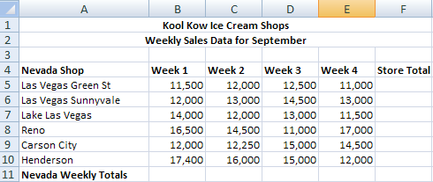

- You will now create an embedded chart.
- Select cells A4 to E10.
- Go to the Insert tab on the standard toolbar.
- Select Column Chart/select the 1st 3D chart.
- The chart displays in the middle of the window in a rectangle.
- Click and Drag the chart so that the upper edge of the chart sits between cells A16 and G16, and the bottom edge of the chart sits between cells A30 and G30.
- Save as Excel Assignment 5.
- Hand in according to instructions.

COMPUTER TECHNOLOGY
EXCEL ASSIGNMENT 6
Create a Pie Chart on Chart Sheet

A chart sheet shows a chart by itself in a separate sheet. It is still linked to the data in a worksheet.

- Create a new worksheet.
- In Cell A1, type: TOP FIVE POPULAR
- In Cell A2 type: ICE CREAM FLAVORS
- In cell A3 type: (In percent)
- In cell A5 type: Flavor. Format in any font, bold.
- In cell B5 type: % . Format in any font, bold.
- Beginning in Cell A6 to A11 type the following:
Vanilla
Chocolate
Butter Pecan
Strawberry
Neapolitan
All other
- Beginning in Cell B6 to B11 type the following:
29
8.9
5.3
5.3
4.2
47.3
9. Save the worksheet as Excel Assignment 6.
10. You will now create a Chart sheet
- Select cells A6 to B11.
- Press F11
- A new sheet is inserted called Chart 1
11. Right click in the white area of the chart and a dialog box appears. Choose Change Chart Type
12. Choose Pie from the chart list and select the first pie chart.
13. Click OK and your chart is now a pie shape.
14. In the top formatting bar, choose Chart design.
- Click on the first chart design box. You now have labels and a place to add a title.
- Double click on the title box and type: Top Five Ice Cream Flavors
- Click on the layout tab under chart tools (on the top formatting bar)
- Choose Show legend at the bottom.
- Click the data label tab. Scroll to More data label options, and click on percentage and close.
- Click in the title box are to the right of Flavors.
- Press Enter and type By: (your name)
- Click outside the title box and re save the chart.
15. Hand in according to instructions.

