Formatting Assignment—Practice using your formatting bar under the HOME tab.
Center this line
Make this line Bold
Underline this line
Spill check this line
Highlight this line in yellow
Change the color of this line to purple.
Right align this line.
Change the font size to 36 on this line.
Change the font type to Baveuse on this line.
Copy this line and Paste it underneath two times.

Write your name in Word Art, and then put it at the top of your assignment.
Insert (using the insert tab) a picture of a computer at the bottom of your assignment.
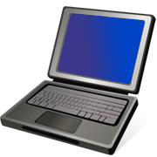
Turn in this assignment electronically (in the hand in folder)

