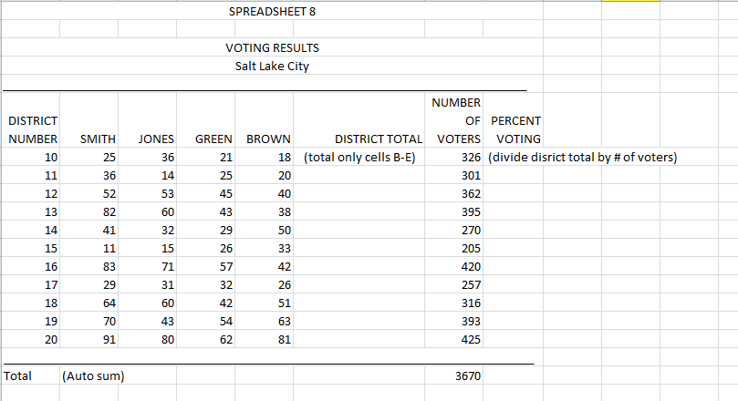
- Enter All headings as shown above (Voting Results/Salt Lake City) Merge and Center.
- Make the line in the next row by holding down the shift key and typing the underline key (next to the 0 key)
- Type in the column headings.
- Type only the 10 in Column 1. Highlight down the column with the small black plus. (lower right hand corner) and click on the small box at the right corner of the highlighted cells. Click on Fill series. Numbers typed in a sequence will be entered for you.
- In the DISTRICT TOTAL column, add the first row using the Auto Sum button. Copy the formula down the column.
- The formula for the PERCENT VOTING column is: DISTRICT TOTAL/# OF VOTERS. Remember to start the formula with=.
- On the TOTAL row at the bottom, add the columns. Do not total the numbers in column 1.
- Right align and bold the column headings.

