Go to the following website and create this crossword puzzle in Excel.
http://www.internet4classrooms.com/excel_puzzle.htm

Making an Interactive Crossword Puzzle with Excel
Let's make a crossword puzzle that will tell us if we type the right letters or not. We will start with four small words which form a square.

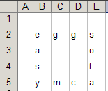

Open Excel and type the letters above in the same places you see them. [I made the columns narrow, but you can wait on that]
- Click on the letter A in gray (column heading), leave your mouse button depressed and drag over to column heading F.
- Put your cursor on the line between any two column headings, click and drag until Excel informs you that you have a column width of 7.00 (54 pixels).
- Click on the number 1 in gray (row heading), leave your mouse button depressed and drag down to row 6.
- Put your cursor on the line between any two row headings, click and drag until Excel informs you that you have a column height of 37.50 (50 pixels).
- Click on the letter E in cell B2, leave your mouse button depressed and drag to the letter a in cell E5. All letters should now be highlighted.

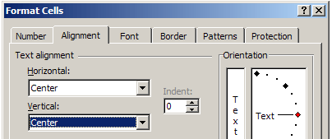
- From the Format menu select Cells , then select the Alignment tab
- Select Center alignment from both the Horizontal and Vertical blocks.
- Click on the Font tab, and select 24 in the size box.
- Click on the Border tab. Select Outside and then also select Inside. Click OK .

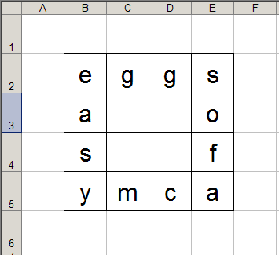

The next step will be to color all of the squares without letters in them.
- Click in cell A1 (on your Excel worksheet, not on the picture above), depress the Ctrl key and leave it depressed until you have clicked on all squares that do not have letters in them. If you click and drag you must release the mouse button at the end of a line (but do not release the Ctrl key). Now click and drag another line of cells, until all are highlighted. (Note: The last cell selected will be outlined in black, but not filled with the highlight color. It is selected)
- Release the Ctrl key (but do not click on the worksheet), and click on the Fill Color button on the Formatting toolbar. [I selected yellow.]

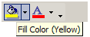

Two steps to go! Next you will add comments at the starting letter of each word, to serve as a clue to the word.
- First, the letter e. This one will require a clue for across and a clue for down. Put them in the same comment with an empty line between the two clues.
- Right-click the letter e (in cell B2) and select Insert Comment. Highlight anything that is already in the comment box and type the clues.
- Continue until you have clues written for each word.

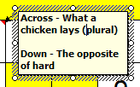

Final Step! This step is what makes the puzzle interactive. If someone types the wrong letter in a box, the letter will turn red when they hit the Enter key. This process is called setting conditional formatting.
- Click on the letter e in cell B2.
- From the Format menu select Conditional Formatting.
- In the Condition 1 window change the middle box to "equal to" and in the long box to the right type the letter e.
- Select the Format button and select a color you wish to use for correct letters. Some people use green (for Go) but I think blue shows up better.
- Click OK .

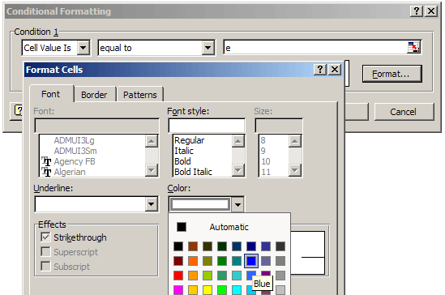
- With the Conditional Formatting window still open, click the button labeled Add >> .
- In the Condition 2 section, select "not equal to", type the letter e in the box to the right and select the Format button to select the color Red for incorrect letters.
- Click OK . The letter e turns blue.
- With the letter e still selected find the Format Painter button on the Standard toolbar. It looks like a paint brush.
- Double-click the paint brush.
- One at a time, click on each of the other eleven letters. ["Trust me, there is method to my madness."]
- Each of the other letters should now be red, because they have been formatted incorrectly. Right? [Psst! The answer is "Right!"]
- Select the letter g in cell C2
- From the Format menu, select Conditional Formatting . See what pops up? See the Method in my Madness?

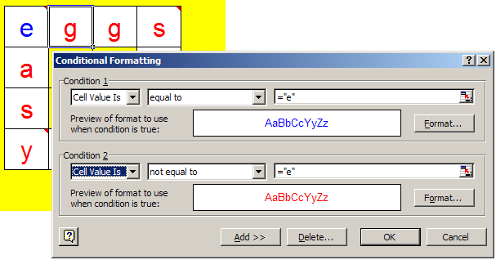
- All that you have to change in the Conditional Formatting window is the letter. Be sure to change only the letter. Leave the quotation marks. Also, make sure you change both letters.
- Repeat this process until all twelve letters in your puzzle are blue.
- Delete the letters. The Comment and formatting instructions will still be in each cell.
- Save your work.

